**Connection ClearVideo64.C to Sixty Clone PCB based on ASSY 250466**

Here is a Sixty Clone “Long Board” ASSY 250466 based on the original Commodore PCB layout.

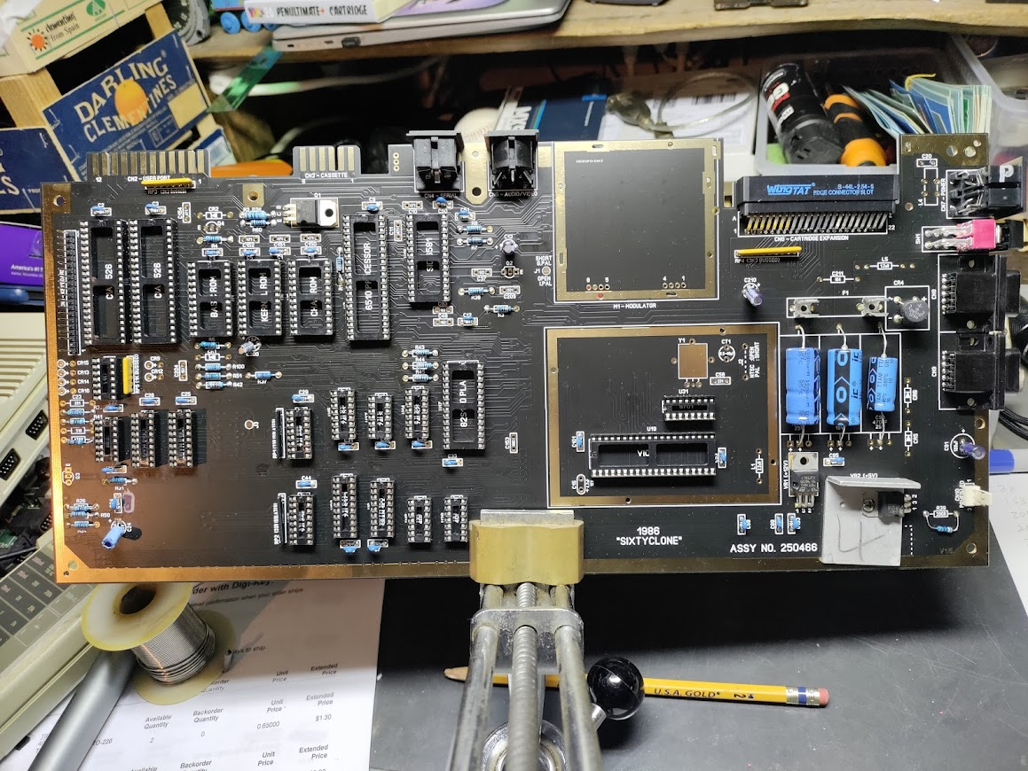

Closeup of RFM location.

Note through hole connection points labeled from Right to Left, 1-4 and 5-8

The ClearVideo64 Board has corresponding through hole connection points with the same numbering.

For newer C64 “short” PCBs and the ClearVideo64 the signals on each connection point are:

1 NC

2 Luma IN

3 NC

4 Chroma IN

5 Composite OUT

6 Luma OUT

7 Chroma OUT

8 Audio IN

From what I have read, the older “long” boards have different signals IN/OUT for some of these connection points than do newer “short” boards. Short boards can be connected simply using 1x4 headers. For the ASSY 250466 1x4 connectors can be modified alongside wired connections to allow the differences.

The connection points that need to be connected are as shown, some using pins from a modified 1x4 header, and some using flexible wire.

|  |  |  |
| --- | --- | --- |
| **ASSY 250466 Connection Point**  **(numerical order)** | **Signal** | **ClearVideo64 Connection Point**  **(not in numerical order)** |
| 1 (NC) | - | 1 (NC) |
| 2 (PIN) | Luma IN | 2 (PIN) |
| 3 (WIRE) | Chroma IN | 4 (WIRE) |
| 4 (WIRE) | Audio IN | 8 (WIRE) |
| - | - | - |
| 5 (PIN) | Composite OUT | 5 (PIN) |
| 6 (PIN | Luma OUT | 6 (PIN) |
| 7 (PIN) | Chroma OUT | 7 (PIN) |
| 8 (NC) | - | 3 (NC) |

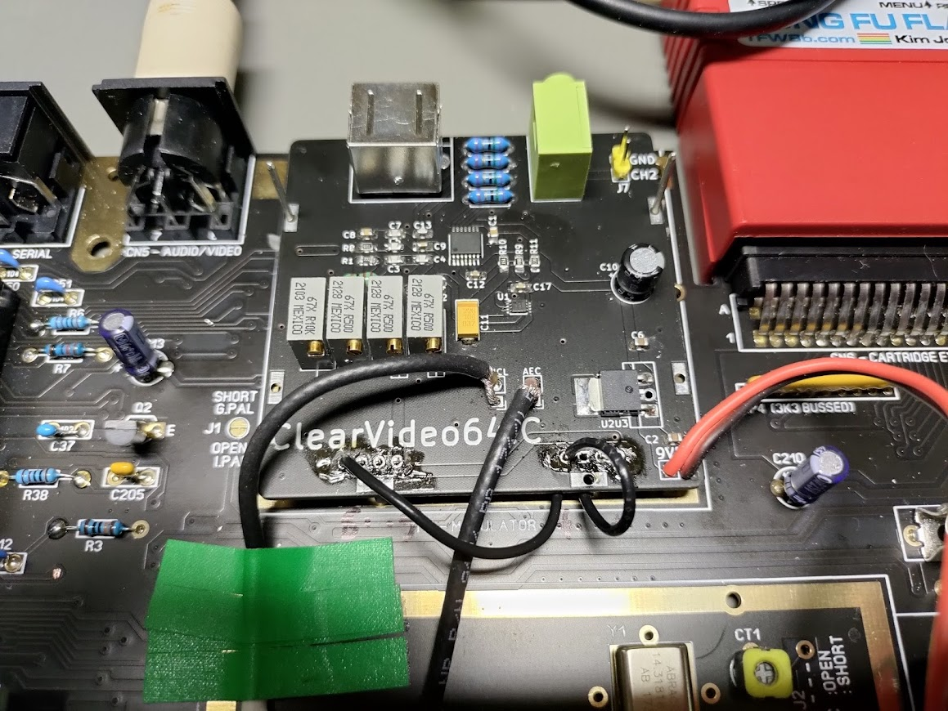

Note also that on this board there is no 9VDC, however, there is 12VDC available across the “middle” large electrolytic capacitor. Jay confirms 12VDC is will safely power the ClearVideo64 as it is capable of using up to 25VDC for a power source.

The last two connections are AEC and PHI0. These signals can be found on the VICII chip pins 16 and 17 respectively. I felt it would be best to find locations on the PCB close to the RFM for the physical connections. This last image shows two points that worked well for my installation (before the above mentioned changes were made).

